Your First Week

By Simon Moss

Introduction

You might have spent months, even years, awaiting this moment: your first week in your graduate research degree. You might have expected to be able to progress immediately and follow your passions. But often, in the first week or even longer, you might discover that you are not sure how to proceed. You feel uncertain or perhaps confused. This document is designed to help you resolve these concerns and start your journey. As this document indicates, in your first week or so, you should attempt to

- contact some key individuals—such as the Head of Postgraduate Studies in your school, your supervisors, and some peers
- organize access to your email and internet—as well as to a computer, printer, and office space if studying on campus
- skim one or more theses—as well as other publications
- clarify your rights and responsibilities—especially around milestones, finances, facilities, and safety

  Did you know | If people complete three challenging or unnatural tasks each morning, such as brush their teeth with the wrong hand, their capacity to maintain effort across the day improves

Contact Key Individuals

During your first week, you should, if at all possible, meet your supervisors and HDR administrators in your school, faculty, or centre as well as perhaps the Head of Postgraduate Studies and a few peers. The following table clarifies how you can meet these individuals.

Person | Role | How to contact this person
Your principal supervisor | - This supervisor is assigned the responsibility to endorse all key decisions about your project, such as which academics should examine the thesis | - As soon as possible, email or telephone your principal supervisor to arrange a meeting  - Your principal supervisor might introduce you to other research candidates or relevant staff
Your co-supervisors | - Your other supervisors could assume many roles—such as your main contact or a subject matter expert | - You are welcome to email or telephone these supervisors to arrange a meeting  - Or you could ask your principal supervisor to arrange a meeting with all your supervisors
HDR administrator or administrators in your school, faculty, or centre | - These staff assist on administrative matters—especially around travel, workspaces, computer facilities, photocopying, phones, or project funding | - You could seek the contact details of these staff from your principal supervisor  - You could then arrange to meet these staff in person or online
Graduate research school | - These staff are your main contact around other administrative matters, such as scholarships, leave, extensions, changes to candidature, and submissions of theses | - Contact graduate-research-school@uow.edu.au
Head of Postgraduate Research | - This person is your main contact when academic challenges unfold, such as uncertainty about expectations | - You could seek the contact details of this person from your principal supervisor, from your HDR administrator, or from graduate-research-school@uow.edu.au

Organise access to your email, internet and other technologies

To gain access to IT resources, such as your student email or helpful software, you first need to activate a computer account. Here are some details about how to access your computer account

…

Did you know | After individuals contemplate how the future will be different in 50 years—such as changes in technology, science, and social communities—their creativity improves.

Locate these and publications to read

During your first week, you should read, or at least skim, one or two past theses. To locate theses that UOW candidates have completed in the past, visit https://ro.uow.edu.au/thesesuow/. This webpage is a repository of all the research at UOW.

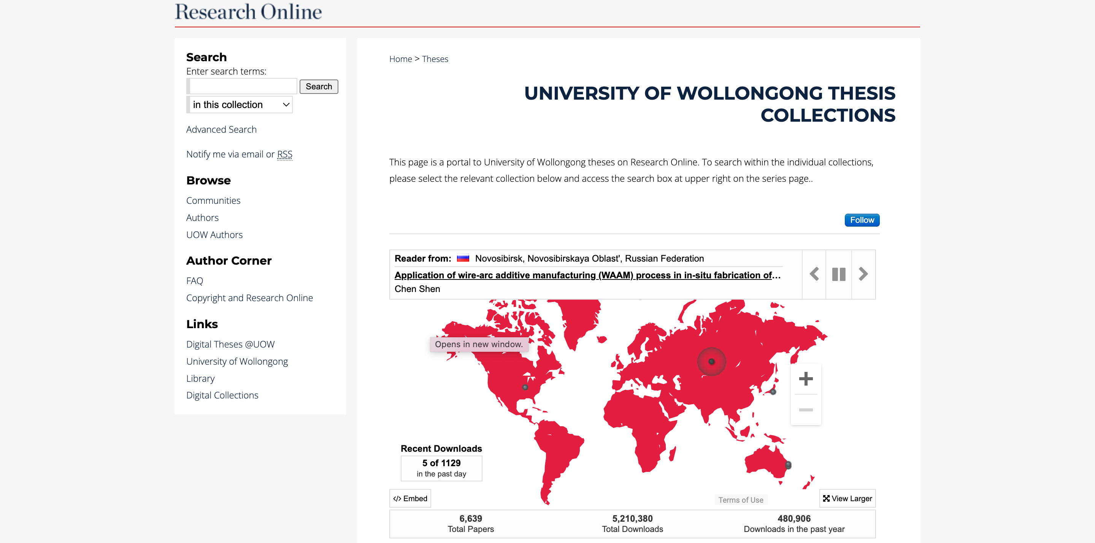

Once you access this webpage

- to locate theses that could interest you, in the search box, enter terms that are relevant to your interests
- to access a thesis, you usually need to click the pdf icon that appears. If no pdf icon appears, the thesis is not yet accessible.

Besides theses, you could read a few other publications that are relevant to your work. To locate relevant publications from the UOW library, visit https://www.uow.edu.au/library/ and then enter relevant terms in the search box.

Clarify your rights and responsibilities

During your candidature, you will gradually learn about the expectations you should fulfill, the tasks you should complete, and the regulations you should follow. However, within the first couple of days, you should perhaps clarify the most vital expectations, tasks, and regulations.

Milestones

During your research degree, your main goal is to submit your thesis on time. However, you also need to complete some other tasks as well. To learn about these tasks, read these webpages.

Did you know | When people conceptualise a task as multi-tasking—that is, they convince themselves they are completing two tasks concurrently—their performance actually improves.

Intellectual property

In consultation with your supervisors, you should answer these questions—either in your first week or soon after.

Is your project subject to a funding agreement? | Yes No
Does your project affect a larger ongoing or planned research project at UOW? That is, if nobody except you could access the results or outcomes of this project, would other researchers at UOW be disadvantaged? | Yes No
If you answered Yes to one of the two previous questions

- you may need to assign your Intellectual Property to the University
- in consultation with your principal supervisor, the Research Support Services office will organise this assignment of Intellectual Property to the University

